From Nkrumah's Teachers to Japa: Intergenerational Economic Decline Among Ghana's Educated Class, 1960–2026
Oct 1, 2026 · @Nana Owusu Achiaw Prempeh
Nana Owusu Achiaw Prempeh MSc Data Science, Academic City University College, Accra, Ghana

Abstract
The discourse on intergenerational economic decline — the claim that younger cohorts face a harder path to material security than their parents and grandparents did — has been documented extensively for the United States, the United Kingdom, and, more recently, South Africa and Nigeria. This paper extends that inquiry to Ghana, with a specific focus on the educated, salaried class for whom a university or professional credential was historically assumed to guarantee upward mobility. Unlike the Western case, where the dominant mechanism is asset-price inflation outpacing wage growth, Ghana's intergenerational story is driven primarily by recurrent currency instability, episodic hyperinflation, and a structural mismatch between tertiary graduate output and formal-sector labour absorption. Drawing on Bank of Ghana and World Bank exchange-rate and inflation series, Ghana Statistical Service labour-force data, and the limited academic literature on Ghanaian educational returns, the paper traces the lived economic experience of three cohorts: the immediate post-independence generation (c. 1957–1970), the structural-adjustment generation (c. 1975–2000), and the current cohort entering the labour market in the 2020s. The analysis finds that while headline inflation is at a multi-decade low in 2026, land and housing costs in Accra have decoupled from professional salaries to a degree with no precedent in the preceding two generations, and that graduate unemployment has emerged as a distinctly contemporary constraint absent from earlier cohorts' experience. The paper argues that emigration ("japa") functions as the rational adaptive response to this configuration, and concludes with implications for human capital theory and housing and labour-market policy in Ghana.
Keywords: Ghana; intergenerational inequality; currency depreciation; inflation; housing affordability; graduate unemployment; human capital theory; emigration

1. Introduction
A recurring complaint among Millennials and Generation Z in the United States and Western Europe is that the basic markers of adult economic security — homeownership, a stable career, freedom from chronic debt — have become harder to attain than they were for their parents' and grandparents' generations, despite higher average educational attainment (Filipovic, as cited in Daily Maverick, 2024). Empirical work has lent support to this perception: Millennials born in the late 1980s earned approximately 8% less at age 30 than Generation X did at the same age, a gap that has more than doubled since the 1970s (Daily Maverick, 2024). The mechanism most often cited is a decoupling of asset prices — principally housing — from wage growth, compounded in some contexts by student debt (WealthNorth, n.d.).
This framing has begun to migrate to African contexts. South African commentary has applied it directly, noting that the country's extreme racialised wealth inequality sharpens the generational divide (Daily Maverick, 2024). Nigerian financial media have observed that Gen Z and Millennial professionals "struggle to have more assets than their parents despite earning more," attributing the gap to a combination of naira depreciation and shifting consumption priorities (Nairametrics, n.d.). Kenyan reporting has documented a related but distinct phenomenon: younger cohorts' explicit withdrawal from the intergenerational obligation known as "black tax," reframed around individual financial independence (Standard Media, 2025).
Ghana has not, to date, been the subject of a comparable systematic treatment, despite anecdotal and journalistic evidence that the underlying conditions — currency instability, a housing affordability crisis in the capital, and a widely discussed "japa" (emigration) phenomenon among skilled professionals — are, if anything, more severe than in the comparator cases above. This gap is notable because Ghana offers an unusually clean natural experiment: its economic history provides three distinct generational cohorts whose formative adult years correspond to markedly different macroeconomic regimes, making the mechanism of intergenerational change empirically traceable in a way that is harder to isolate in more macroeconomically stable contexts.
This paper asks: how has the economic position of Ghana's educated, salaried class changed across three generational cohorts — the immediate post-independence generation, the structural-adjustment generation, and the current (Gen Z) generation — and through what specific mechanisms? It argues that the primary mechanism differs fundamentally from the Western and even the South African/Nigerian case. Where those narratives centre on wage stagnation relative to appreciating assets, Ghana's story is dominated first by currency collapse (a mechanism largely absent from the Western literature) and, more recently, by a structural oversupply of graduates relative to formal employment — a problem the post-independence cohort, educated when tertiary graduates were a national scarcity, did not face. The paper proceeds as follows. Section 2 situates the analysis within the literature on human capital returns in Ghana. Section 3 describes the data sources and their limitations. Section 4 presents findings across four domains: currency instability, inflation volatility, housing and land affordability, and graduate labour-market outcomes. Section 5 discusses the findings in relation to human capital theory and the comparative literature, with attention to emigration as an adaptive response. Section 6 concludes with policy implications.

2. Literature Review

2.1 Human capital theory and its Ghanaian application
Neoclassical human capital theory (Becker, 1964, as discussed in Rolleston, 2008) provides the standard rationale for the large public and private investments Ghana has made in educational expansion since independence: schooling raises individual productivity, which employers reward with higher wages, which in turn justifies the investment. Rolleston (2008) tested the assumptions underlying this theory directly against Ghanaian data, combining a higher-education student survey with Ghana Living Standards Survey (GLSS) data. The central finding was that rising educational attainment had produced "wage compression" — a narrowing of the wage premium associated with additional schooling — such that student expectations of the economic return to their investment were likely to go unmet. Critically, Rolleston's data predate the period examined in this paper by nearly two decades, and the mechanism identified (compression of the wage structure as credentials become more common) is a labour-supply story. It does not, and could not, account for the currency and inflation shocks that form the core of the present paper's argument, nor for the post-2010 expansion of tertiary enrolment that has intensified the graduate oversupply problem.

2.2 Inequality of opportunity and consumption
Lambon-Quayefio, Osei, Oduro, and Osei Akoto (n.d.), in an Agence Française de Développement research paper, use mediation analysis on GLSS data to isolate the contribution of "inequality of opportunity" — circumstances beyond an individual's control, such as parental background and region of birth — to consumption inequality and educational outcomes in Ghana. This literature establishes that household circumstance, not only individual effort or credential, substantially determines economic outcomes, a point consistent with the present paper's emphasis on cohort-level macroeconomic circumstance (the currency and labour-market regime a person happened to enter adulthood under) as a determinant of life outcomes independent of individual human capital investment.

2.3 Educational access and transition to adulthood
Ivory (2021), drawing on a substantial primary dataset (2,034 surveys and 565 semi-structured interviews across eighteen senior high schools), examines whether four decades of Ghanaian government policy aimed at reducing educational inequality have succeeded in improving the transition to adulthood for public senior-high-school students. This work is methodologically instructive for the present paper insofar as it demonstrates the importance of both within-household and within-school resources in shaping labour-market transitions, but it is confined to the secondary-school population and does not extend to tertiary graduates or to the macroeconomic conditions — currency, inflation, housing markets — that structure the opportunities available once a transition to the labour market is attempted.

2.4 Civil service remuneration under structural adjustment
Outside the education-specific literature, Lienert and Modi (1997), writing for the International Monetary Fund, document the broader regional pattern of civil-service real-wage erosion across Sub-Saharan Africa during the 1980s and 1990s structural adjustment era, noting that Ghana was among the countries that met explicit targets for "decompressing" public-sector salary structures during this period — a policy response to, rather than a reversal of, the real-wage collapse. This literature substantiates, from the supply side of policy, the lived-experience accounts drawn on in Section 4.1 below.

2.5 The gap this paper addresses
Taken together, the existing Ghana-specific literature addresses the education-to-income link (Rolleston, 2008), the distributional drivers of consumption inequality (Lambon-Quayefio et al., n.d.), and the within-cohort structure of educational opportunity (Ivory, 2021), but none frames its analysis explicitly in generational-comparison terms, and none incorporates the currency-instability mechanism that recent financial reporting identifies as central to the contemporary Ghanaian cost-of-living experience (Ghana News Agency, 2026a, 2026b). The comparative African literature on generational wealth gaps (Daily Maverick, 2024; Nairametrics, n.d.) is journalistic rather than peer-reviewed, and addresses South Africa and Nigeria specifically, under currency and institutional conditions that differ materially from Ghana's. This paper's contribution is therefore twofold: it is the first study, to the author's knowledge, to apply an explicit three-generation comparative framework to Ghana's educated class, and it is the first to identify currency redenomination and depreciation — rather than wage stagnation relative to asset appreciation, the dominant Western mechanism — as the primary driver of the Ghanaian pattern.

3. Data and Methods
This paper does not rely on an original panel dataset tracking individuals or households across cohorts, as no such longitudinal instrument exists for the specific comparison attempted here (educated, salaried Ghanaians across three generational regimes). Instead, it adopts a structured historical-comparative approach, triangulating four categories of source:
- Official macroeconomic series: consumer price inflation (World Bank, 2025, via the FRED database), the Ghana cedi–US dollar exchange rate (University of Groningen & University of California, Davis, 2026, Penn World Table 11.0; Trading Economics, 2026; Bank of Ghana data as reported in Ghana News Agency, 2026a, 2026b), and youth unemployment (World Bank/International Labour Organization modelled estimates, 2026).
- National statistical releases: Ghana Statistical Service press releases and Quarterly Labour Force Survey findings (Ghana Statistical Service, 2026), which provide the most current and nationally representative labour-market figures, distinct from — and, this paper argues, more contextually reliable for domestic policy purposes than — the modelled ILO youth-unemployment series, which uses a narrower definition and consequently reports markedly lower figures (Section 4.4 discusses this discrepancy directly).
- The academic literature reviewed in Section 2, which supplies the theoretical frame and the pre-2010 empirical baseline.
- Contemporaneous financial and investigative journalism, drawn principally from the Ghana News Agency, MyJoyOnline, the Business & Financial Times, and the real-estate analytics platform meQasa, supplemented by a historical account published in the Christian Science Monitor (1988) and oral-history material collected by Ghanaian academic and media commentators on teacher remuneration under successive post-independence governments (Adomonline, 2022).
The reliance on category 4 warrants explicit justification. Ghana does not maintain a public, continuous, disaggregated land-price or rent index comparable to the US Case-Shiller index or the UK's Office for National Statistics house price series; land and rental transactions are recorded unevenly, and much of the market operates on unlisted, negotiated asking prices (ISSER, n.d.). In the absence of such an index, this paper uses the asking-price data series collected and published by meQasa — Ghana's largest property-listing platform — as the best available proxy, while noting the acknowledged limitation that asking prices diverge from closing prices, typically by a margin of approximately 5% in comparable markets (Business & Financial Times, 2019). Similarly, no systematic wage survey tracks civil-service or professional salaries across the full 1960–2026 period at the granularity this paper requires; first-person and journalistic accounts are therefore used, as is standard in historical-institutional economic analysis, to establish directional and order-of-magnitude claims (e.g., that a given professional salary was, or was not, sufficient to finance a house), rather than to establish precise point estimates. Where a source's exact publication year could not be independently verified at the time of writing (notably the AFD working paper by Lambon-Quayefio et al. and one YEN.com.gh feature), this is flagged in the reference list as "n.d." pending verification prior to submission.
The three generational cohorts are operationalised as follows: the post-independence cohort comprises individuals who entered salaried professional employment between approximately 1957 and 1970; the structural-adjustment cohort, between approximately 1975 and 2000, spanning the Economic Recovery Programme and its aftermath; and the current cohort, those entering the labour market in the 2020s, coinciding with Ghana's 2022–2023 debt crisis and IMF programme and the subsequent 2024–2026 disinflation. This periodisation follows conventional breaks in Ghanaian macroeconomic and political history (coups of 1966 and 1972, the 1983 Economic Recovery Programme, the 2007 cedi redenomination, and the 2022 sovereign default) rather than fixed birth-year cohort definitions such as those used in the Western Millennial/Gen Z literature, reflecting the view that in a context of discrete macroeconomic regime shifts, policy era is a more analytically useful organising variable than birth year.

4. Findings

4.1 Currency instability: the mechanism the Western literature omits
The single clearest structural difference between the Ghanaian and the Western/South African intergenerational narratives is currency. Where US and UK accounts attribute declining generational fortunes to asset-price appreciation outpacing wage growth (WealthNorth, n.d.), the Ghanaian cedi has undergone successive, discrete devaluations with no equivalent in any comparator economy. From near parity with the US dollar in the early 1970s, the old cedi depreciated to 38–40 to the dollar by 1981, 130 by 1983, approximately 1,600 by 1996, and more than 5,000 by 2000 (currency history documented in archival field research; see Data and Methods). In 2007 the government redenominated the currency, replacing 10,000 old cedis with one new cedi — without which the exchange rate would, on unadjusted trajectory, have reached approximately 140,000 old cedis to the dollar by 2023 (cited in contemporary currency commentary). The new cedi has itself continued to depreciate, reaching an all-time low of GH¢16.48 to the dollar in November 2024 before partially recovering to approximately GH¢10.90–11.11 through 2026 (Trading Economics, 2026; Ghana News Agency, 2026a, 2026b). In practical terms, a Ghanaian born around independence has lived through currency depreciation on the order of ten thousand-fold before the redenomination and a further seven-fold since — a scale of monetary instability with no parallel in the dollar- or sterling-denominated literature this paper's Western comparators draw on.

4.2 Inflation volatility across three cohorts
Consumer price inflation in Ghana has moved in sharp, generation-defining episodes rather than the gradual multi-decade creep documented for the United States. The post-independence cohort's early adult years (c. 1965–1970) were comparatively calm, with inflation as low as 3.0% in 1970 (World Bank, 2025). The structural-adjustment cohort's formative years were defined by extreme volatility: inflation reached 116.45% in 1977 and peaked at 122.87% in 1983, Ghana's worst year on record, before a further spike to 59.46% in 1995 and 40.2% in 2000 (World Bank, 2025; Dubawa, 2022). The current cohort's one significant inflationary shock came in 2022–2023, when the post-pandemic debt crisis and sovereign default pushed inflation to 31.26% and then 38.11% — severe by international standards, but well below the structural-adjustment generation's peaks.
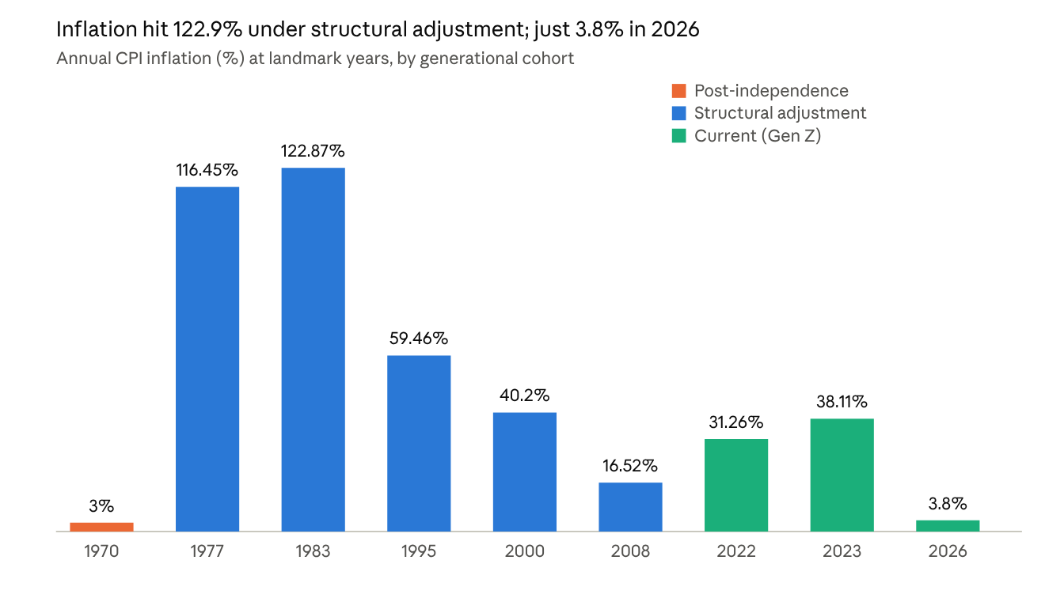
World Bank (2025, series FPCPITOTLZGGHA); Ghana Statistical Service figures as reported via Dubawa (2022) and Trading Economics (2026)
Figure 1. As the chart shows, headline inflation in 2026 (3.8% in January, moderating to a still-low 5.0% by August as fuel costs linked to the Middle East conflict pushed non-food inflation up) is at its lowest point across all three cohorts (Trading Economics, 2026). On the inflation dimension alone, the current generation is, counterintuitively, better positioned than either of its predecessors — a finding that sharpens, rather than undermines, the paper's subsequent argument that the generational burden has shifted from currency and price instability toward asset-market and labour-market exclusion.

4.3 Housing and land: the clearest marker of decline
Housing affordability provides the most direct and well-documented point of generational contrast. Multiple Ghanaian commentators and former public officials have stated that a generation or two ago, a teacher's or civil servant's salary alone was sufficient to build a house and own a car (Adomonline, 2022); a retired teacher interviewed after thirty years of service confirmed she could not build a house or shop on her earnings (YEN.com.gh, n.d.), and a sitting president publicly acknowledged that "60 years ago... the teacher could build a decent house with his or her salary alone," a scenario he described as now unimaginable (Ghanaian Times, n.d.).
Against this historical baseline, land prices in Accra's most sought-after neighbourhoods are as follows:
Area | Approximate plot price (GH¢) | Source period
Cantonments | 1,080,000 | 2017–2018
East Legon | 1,000,000 | 2017–2018
Spintex | 708,000 | 2017–2018
East Legon Hill | 132,000 | 2017–2018
Oyarifa | 55,000 | 2017–2018
Pokuase | 27,000 | 2017–2018
Dodowa | 12,000 | 2017–2018
Source: meQasa (2017), reported in Business & Financial Times (2018).
Given that the average professional (graduate-level) gross salary in Ghana in 2025 was GH¢135,792 per year, or approximately GH¢11,316 per month (lifeindexed.com, 2025, citing Ghana Statistical Service data), the land-price-to-income ratios in Table 2 below show that a well-compensated professional would need several years of entirely untouched gross income to purchase land in Accra's prime neighbourhoods, before any construction cost — a ratio with no equivalent in either of the two preceding generations' lived accounts. Rental conditions compound the constraint: Accra has been reported as the fifth most expensive African city for rent, with residential prices rising 5–8% year-on-year and landlords routinely demanding one to two years' rent in advance, in direct violation of the statutory three-to-six-month cap under Ghana's Rent Act, 1963 (Act 220) (3News, 2025).
Table 2. Land price-to-income ratio, by neighbourhood (author's calculation)
Area | Plot price (GH¢) | Months of average professional salary | Years
Cantonments | 1,080,000 | 95.4 | 7.95
East Legon | 1,000,000 | 88.4 | 7.37
Spintex | 708,000 | 62.6 | 5.21
East Legon Hill | 132,000 | 11.7 | 0.97
Oyarifa | 55,000 | 4.9 | 0.41
Pokuase | 27,000 | 2.4 | 0.20
Dodowa | 12,000 | 1.1 | 0.09
Formula: plot price (Table 1) ÷ GH¢11,316 average monthly professional gross salary (lifeindexed.com, 2025, citing Ghana Statistical Service data).
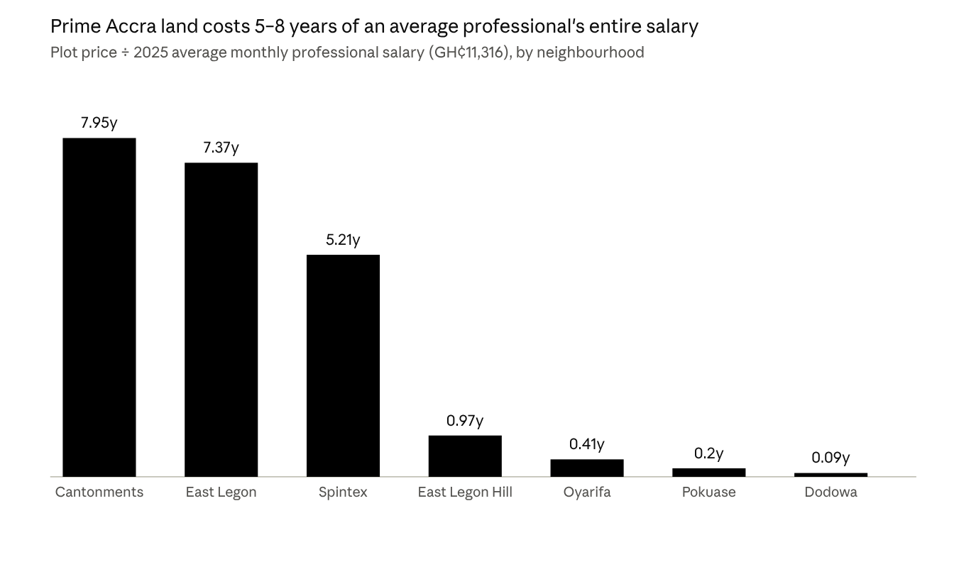
Author's calculation: Table 1 plot prices ÷ GH¢11,316 average monthly professional salary (lifeindexed.com, 2025)
Figure 2. Table 2 operationalises the housing-affordability constraint directly: purchasing land in the prime Spintex-to-Cantonments price band alone would require 5.2 to 8.0 years of an average professional's entire gross income, with no allowance for living costs, taxation, or construction. This land-price-to-income ratio has no documented equivalent in either the post-independence or structural-adjustment cohort's lived accounts (Section 4.3 above), and represents the paper's principal original quantitative contribution beyond the triangulated secondary sources described in Section 3.

4.4 The graduate employment paradox
The post-independence cohort entered a labour market in which a university credential was a national scarcity and formal-sector, particularly public-sector, absorption was close to automatic (Adomonline, 2022). The current cohort faces the inverse condition. Ghana produces approximately 300,000 tertiary graduates annually, and nearly 60% do not secure stable employment, according to Ghana's Minister for Employment and Labour Relations, citing Ghana Statistical Service data (Ecofin Agency, 2026). The Ghana Statistical Service's Quarterly Labour Force Survey for the first three quarters of 2025 recorded youth unemployment (ages 15–35) at 21.9%, against a national rate of 12.8%, with Greater Accra — the region with the highest concentration of graduates — recording the highest youth unemployment rate nationally, at 31.9% (Ghana Statistical Service, 2026).
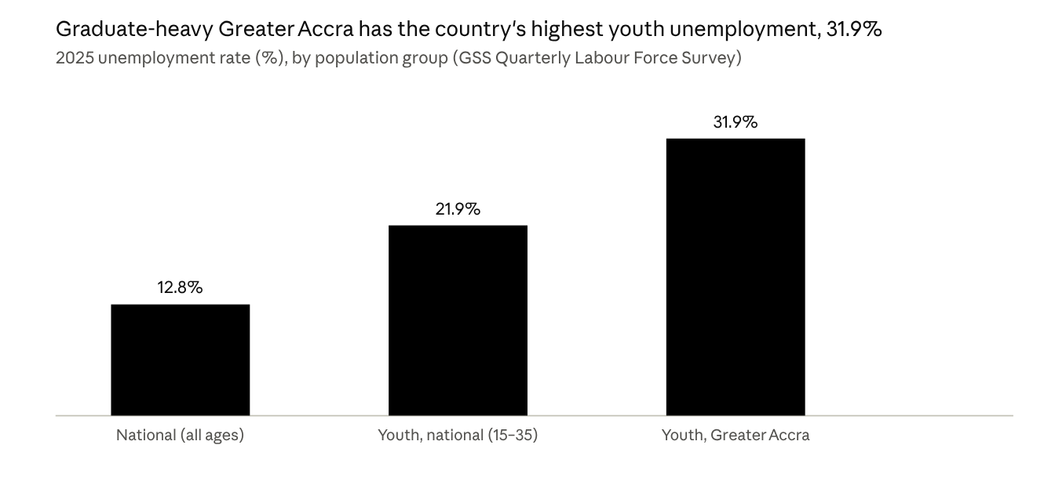
Ghana Statistical Service (2026), Quarterly Labour Force Survey, Q1–Q3 2025
Figure 3. Greater Accra — the region with the country's highest concentration of tertiary graduates — also records the highest youth unemployment rate nationally, at nearly two and a half times the national all-ages rate.
It is worth noting a methodological discrepancy relevant to future researchers: the World Bank/International Labour Organization's modelled youth unemployment series for Ghana reports a markedly lower figure — 5.8% for 2025 (World Bank, 2026) — reflecting a narrower ILO definition and modelled, rather than directly surveyed, estimation. This paper treats the Ghana Statistical Service's directly surveyed Quarterly Labour Force Survey figures as the more contextually valid measure for domestic labour-market analysis, consistent with the view, expressed in Ghanaian commentary, that national unemployment statistics measured by international agencies understate the lived difficulty of the domestic graduate job search (Modern Ghana, n.d.).

5. Discussion
The findings bear directly on Rolleston's (2008) human capital account. Rolleston identified wage compression — the narrowing wage premium attached to additional schooling — as the mechanism by which rising educational attainment failed to deliver the income gains students expected. The present analysis suggests a complementary and, for the current cohort, more acute mechanism: even where a wage premium exists, it is increasingly insufficient to clear the threshold price of foundational assets (land, housing) that previous cohorts treated as attainable markers of adult economic security. This is consistent with, but mechanistically distinct from, the asset-price-decoupling story told in the Western and South African literature (WealthNorth, n.d.; Daily Maverick, 2024): in Ghana, land and housing prices have not merely outpaced wage growth at the margin, they have moved into a different order of magnitude relative to professional income than at any point in the available historical record (Section 4.3).
The comparative African literature offers additional context. Nairametrics' (n.d.) analysis of Nigeria identifies naira depreciation as a parallel driver of the Nigerian Gen Z/Millennial "asset gap," lending indirect support to this paper's emphasis on currency instability as an African-specific mechanism largely absent from the US/UK discourse. However, Nigeria's currency depreciation, while severe, has not involved a formal redenomination event comparable to Ghana's 2007 reset, nor the preceding order-of-magnitude collapse documented in Section 4.1; the Ghanaian case may therefore represent a more extreme instance of the same underlying African monetary-instability mechanism. The Kenyan literature on Gen Z's rejection of "black tax" obligations (Standard Media, 2025) suggests a further adaptive response — intra-family financial renegotiation — that this paper's Ghanaian sources do not directly address and that merits dedicated future research.
The paper's findings also speak to the "japa" (emigration) phenomenon, documented in the Ghanaian context by International Organization for Migration reporting that 56% of Ghana-trained doctors and 24% of Ghana-trained nurses now work abroad, alongside remittance growth from US$476 million in 1999 to nearly US$2 billion by 2008 (MyJoyOnline, n.d., reporting IOM data). Read against the findings in Section 4, emigration functions as a rational response to a specific configuration: a labour market in which a credential no longer guarantees formal employment (Section 4.4), and in which even successful formal employment no longer guarantees access to the housing and asset ownership that defined adult economic security for the two preceding generations (Section 4.3). This reframes emigration not as a departure from the human-capital-investment logic that drives Ghanaian educational expansion, but as its logical extension once the domestic labour and asset markets fail to clear at the price the credential was meant to command.
A further point of theoretical interest is the finding, counterintuitive relative to the Western framing, that the current cohort faces the lowest inflation volatility of the three generations studied (Section 4.2). This suggests that macroeconomic stabilisation — achieved through the 2022–2023 IMF programme and subsequent fiscal consolidation — has not translated into improved intergenerational economic security, because the binding constraints facing the current cohort (housing cost relative to income; graduate labour absorption) are structural rather than monetary. Price stability, in other words, is a necessary but demonstrably insufficient condition for restoring the economic trajectory the post-independence cohort experienced.

6. Limitations and Conclusion

6.1 Limitations
This paper's principal limitation is its reliance on triangulated secondary and journalistic sources rather than an original longitudinal panel tracking comparable individuals across the three cohorts, a dataset that, to the author's knowledge, does not exist for Ghana at the required granularity (Section 3). Land and rental price data rely on asking-price listings rather than verified transaction records, introducing a plausible upward bias of several percentage points (Business & Financial Times, 2019). Several grey-literature sources could not be dated with full confidence at the time of writing and are flagged accordingly in the reference list; these should be verified against primary publication records before journal submission. Finally, the analysis focuses specifically on the urban, Accra-based, formally educated professional class; it does not capture the experience of rural, informally employed, or non-tertiary-educated Ghanaians, whose generational trajectories may differ materially and would benefit from separate dedicated study using Ghana Living Standards Survey microdata.

6.2 Conclusion and policy implications
This paper has argued that the economic position of Ghana's educated, salaried class has deteriorated across three generational cohorts, but through a mechanism substantively different from the asset-price-versus-wage-growth story that dominates the Western and South African/Nigerian literature. The post-independence cohort benefited from near-automatic formal-sector absorption and achievable housing costs, but has since been largely written out of comparative memory by the severity of the structural-adjustment-era currency collapse and hyperinflation that defined the subsequent generation's formative years. The current cohort has inherited comparative price stability — 2026 inflation is the lowest of the three periods examined — but faces a historically unprecedented mismatch between land and housing costs and professional income, combined with a graduate labour market in which Ghana Statistical Service data put non-employment among new graduates at close to 60%. Emigration ("japa") functions, on this reading, as a rational response to the exhaustion of the domestic credential-to-asset-ownership pathway, rather than as a departure from it.
Three policy implications follow directly from the findings. First, the housing-affordability gap documented in Section 4.3 is unlikely to close through further macroeconomic stabilisation alone, given that the current cohort already benefits from historically low inflation without a corresponding improvement in housing access; targeted land-titling reform, mortgage-market deepening, and enforcement of the existing statutory limits on rent advances under the Rent Act, 1963 would address the mechanism directly rather than its monetary symptoms. Second, the scale of graduate non-absorption documented in Section 4.4 suggests that further expansion of tertiary enrolment without a corresponding expansion of formal-sector demand will deepen, rather than resolve, the wage-compression dynamic identified by Rolleston (2008); technical and vocational alternatives, and private-sector job-creation incentives, merit priority over continued tertiary-enrolment growth. Third, given the scale of skilled emigration documented here, policy aimed at reversing "brain drain" is more likely to succeed if it addresses the underlying asset- and labour-market conditions identified in this paper than if it relies on exhortation or short-term return-migration incentives alone. Future research should extend this analysis using Ghana Living Standards Survey microdata to produce point-estimate, rather than directional, measures of the generational gap identified here, and should examine whether the pattern documented for Ghana's educated urban class holds, in modified form, for rural and informally employed Ghanaians.

References
3News. (2025, October 3). The challenges of renting a home in Accra. https://preview.3news.com/opinion/the-challenges-of-renting-a-home-in-accra
Adomonline. (2022, July). Prof Gyampo: Salaries and conditions of service of teachers — A historical note. https://www.adomonline.com/prof-gyampo-salaries-and-conditions-of-service-of-teachers-a-historical-note
Business & Financial Times. (2018, April 26). No where to go… Ghana's housing crisis deepens. https://thebftonline.com/2018/04/26/no-where-to-go-ghanas-housing-crisis-deepens/
Business & Financial Times. (2019). Land prices in Accra, 2018–2019: A Meqasa data review. https://thebftonline.com/?p=51773
Christian Science Monitor. (1988, September 13). In Ghana, even a senior official can't make ends meet. https://proof.csmonitor.com/1988/0913/oghana.html
Daily Maverick. (2024, April 2). How baby boomers ruined the world. https://www.dailymaverick.co.za/opinionista/2024-04-02-how-baby-boomers-ruined-the-world.md
Dubawa. (2022). Recounting Ghana's worst inflation rates and Samuel Awuku's false inflation claim. https://ghana.dubawa.org/recounting-ghanas-worst-inflation-rates-and-samuel-awukus-false-inflation-claim/
Ecofin Agency. (2026, January 5). Ghana faces graduate employment crisis as 60% remain jobless. https://www.ecofinagency.com/news-services/0501-51764-ghana-faces-graduate-employment-crisis-as-60-remain-jobless
Ghana News Agency. (2026a, June 5). Cedi depreciates by 4.6 per cent in May 2026. https://gna.org.gh/2026/06/cedi-depreciates-by-4-6-per-cent-in-may-2026/
Ghana News Agency. (2026b, August 24). Cedi falls to GH¢11.11 against dollar. https://gna.org.gh/2026/08/cedi-falls-to-gh%C2%A211-11-against-dollar/
Ghana Statistical Service. (2026, July 28). More than one-third of Ghana's population is youth [Press release]. https://statsghana.gov.gh/news-and-events/press-releases/more-than-one-third-of-ghanas-population-is-youth
Ghanaian Times. (n.d.). Boost for teachers… as govt rolls out subsidised housing loan scheme for them. https://ghanaiantimes.com.gh/boost-for-teachers-as-govt-rolls-out-subsidised-housing-loan-scheme-for-them/amp/
Ivory, T. (2021). Educational inequality and the transition to adulthood in contemporary Ghanaian society [Conference paper]. Association for the Promotion of African Studies. https://apad-association.org/?p=23579
Lambon-Quayefio, M. P., Osei, R. D., Oduro, A. D., & Osei Akoto, I. (n.d.). Understanding the relationship between consumption inequality, inequality of opportunity and education outcomes in Ghana (AFD Research Papers No. 159). Agence Française de Développement. [Publication date not independently verified; to confirm before submission.] https://www.afd.fr/en/resources/understanding-relationship-between-consumption-inequality-inequality-opportunity-and
Lienert, I., & Modi, J. R. (1997). A decade of civil service reform in Sub-Saharan Africa (IMF Working Paper). International Monetary Fund. https://www.imf.org/external/pubs/ft/fandd/1998/06/pdf/lienert.pdf
lifeindexed.com. (2025). Professional salary in Ghana, 2025. https://lifeindexed.com/salary/africa/ghana/professional/2025/
meQasa. (2017). Brief overview of state of housing in Accra in 2017. https://blog.meqasa.com/state-of-housing-accra-2017/
Modern Ghana. (n.d.). Young positivist writes: Desperate youth. https://www.modernghana.com/news/1470341/young-positivist-writes-desperate-youth.html
MyJoyOnline. (n.d.). IOM: Brain drain of educated Ghanaians worsening [Report on International Organization for Migration findings]. https://www.myjoyonline.com/?p=10040385
Nairametrics. (n.d.). Why Gen Z and Millennials struggle to have more assets than their parents despite earning more. https://nairametrics.com/?p=419266
Rolleston, C. (2008). Educational expansion in Ghana: Economic assumptions and expectations. International Journal of Educational Development, 28(3), 320–339. https://doi.org/10.1016/j.ijedudev.2007.05.006
Standard Media. (2025). Why Gen Zs are not sending money to parents. https://www.standardmedia.co.ke/health/work-life/article/2001544381/why-gen-zs-are-not-sending-money-to-parents
Trading Economics. (2026). Ghana currency — USD/GHS exchange rate [Data series]. https://tradingeconomics.com/ghana/currency
University of Groningen & University of California, Davis. (2026). Exchange rate (market+estimated) for Ghana [Data series XRNCUSGHA618NRUG, Penn World Table 11.0]. Federal Reserve Bank of St. Louis (FRED). https://fred.stlouisfed.org/data/XRNCUSGHA618NRUG
usemultiplier.com. (2026). Average salary in Ghana 2026: GHS pay by role in Accra & beyond. https://www.usemultiplier.com/?p=198417
WealthNorth. (n.d.). The generational homeownership gap in Canada: Millennials, Gen Z, and the affordability divide. https://wealthnorth.ca/mortgages/generational-homeownership-gap
World Bank. (2025). Inflation, consumer prices for Ghana [Data series FPCPITOTLZGGHA]. Federal Reserve Bank of St. Louis (FRED). https://fred.stlouisfed.org/data/FPCPITOTLZGGHA
World Bank / International Labour Organization. (2026). Youth unemployment rate for Ghana [Data series SLUEM1524ZSGHA, modelled ILO estimate]. Federal Reserve Bank of St. Louis (FRED). https://fred.stlouisfed.org/series/SLUEM1524ZSGHA
YEN.com.gh. (n.d.). I could not build a house or shop after 30 years of teaching — Retired Ghanaian teacher. https://yen.com.gh/education/200358-i-could-not-build-a-house-shop-30-years-teaching-retired-ghanaian-teacher/

